Open solid edge

1.Select manage🡪 cache assistance🡪 select offline

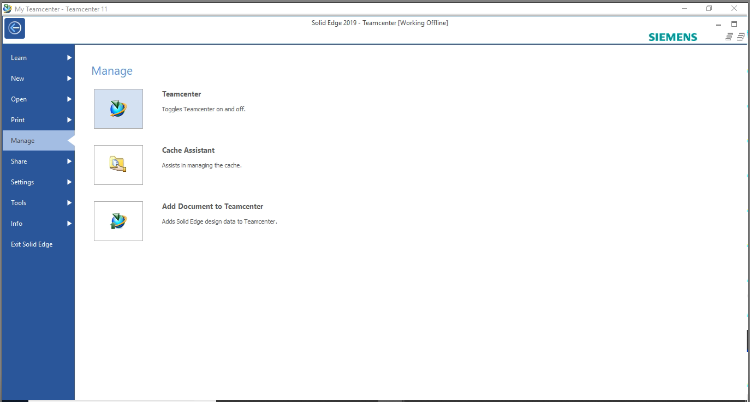

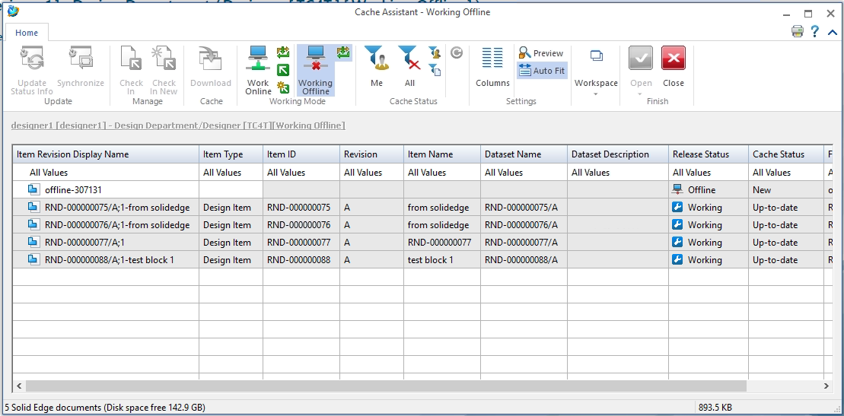

Create a new part in solid edge in offline mode

Save the offline created part

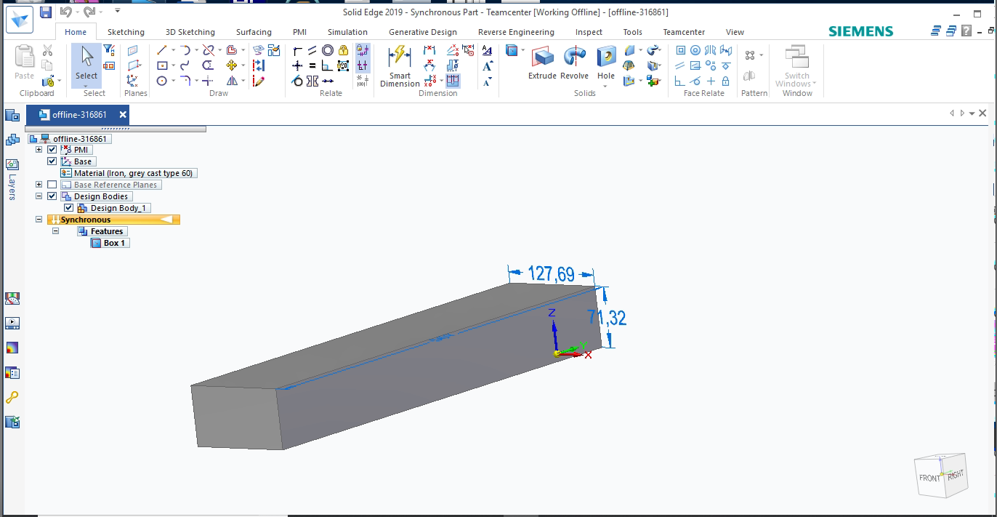

Now to import the part created in teamcenter.

Close the open background window and perform manage🡪 cache assistance🡪 workonline

You will get a login window to login into teamcenter

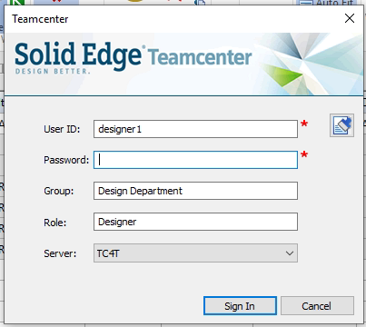

Open the part requied to take online

Click on check –in you will get the below window for id and naming in teamcenter. Enter the details and select perform actions.

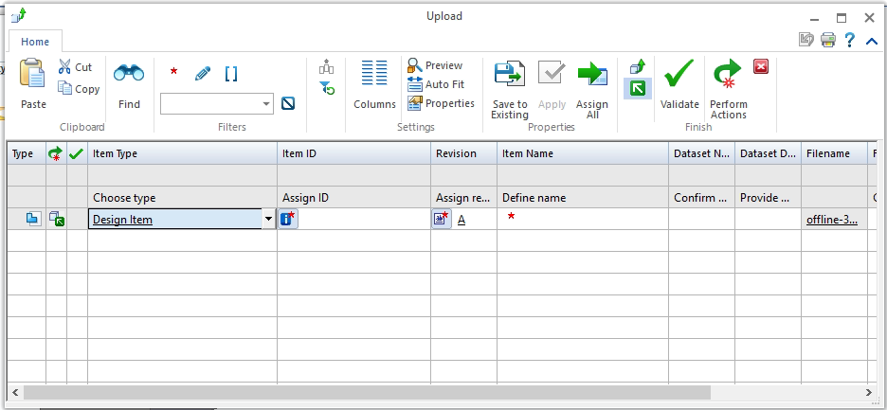

Now open teamcenter and search for the required part number

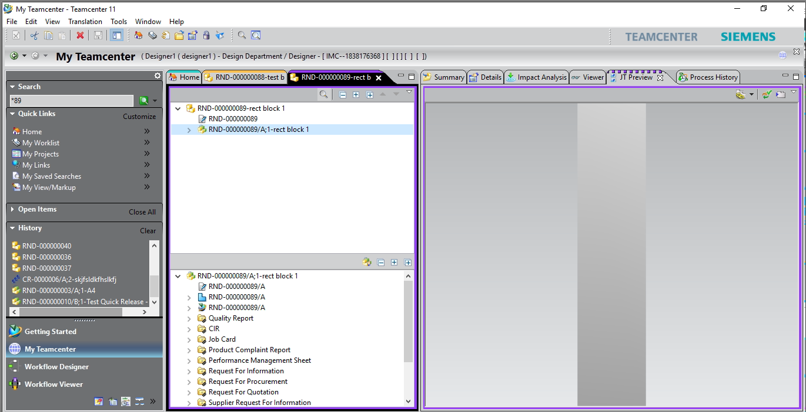

Your part has been successfully added to teamcenter.

Now check out the part from solid edge and take it offline for further modification first check out the part in online mode in solidedge.

Now open manage 🡪 cache assistance🡪

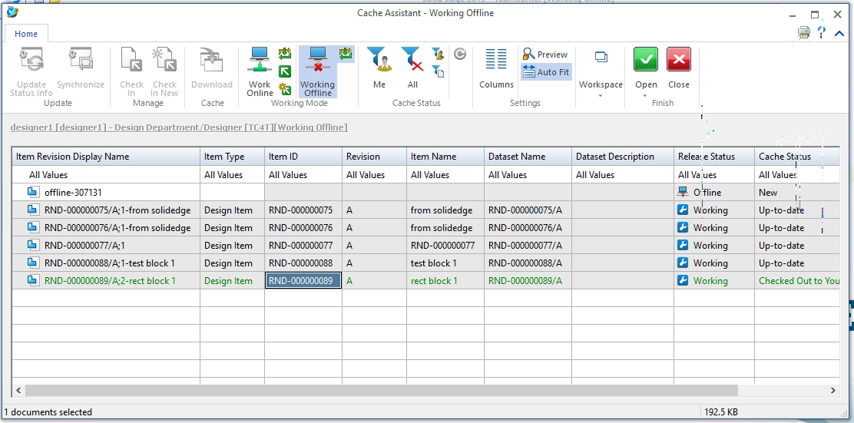

Select the required part to be modified (part which was checked out previously when online).

Modify the part and save it.

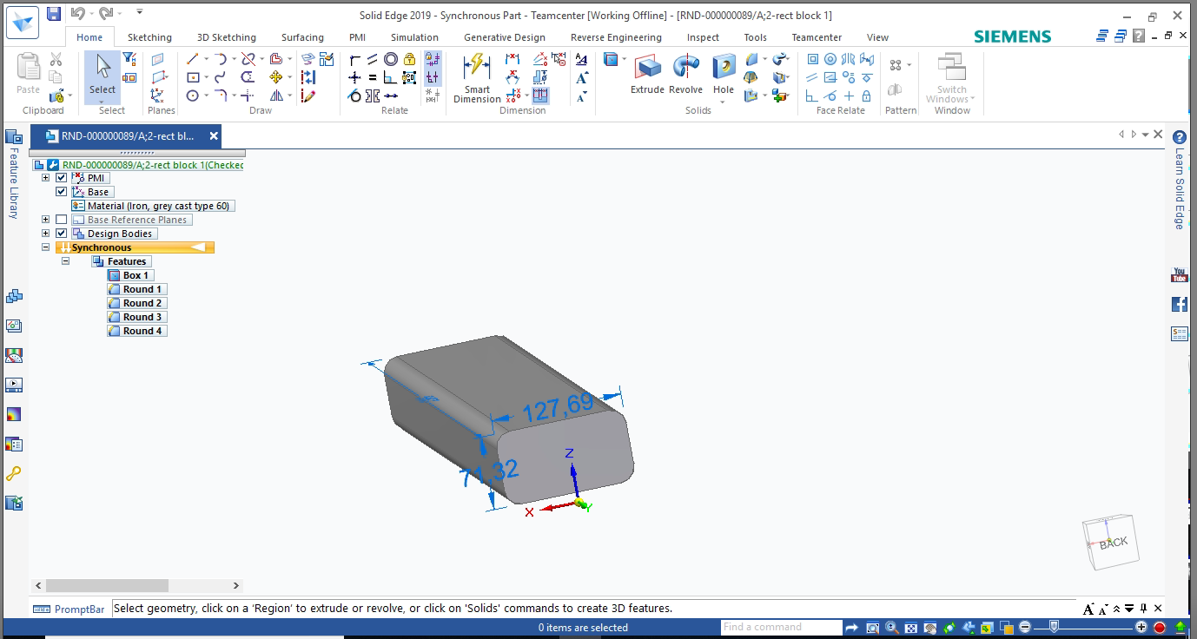

Now take the solid edge in online mode by manage🡪 cache assistance🡪 working online

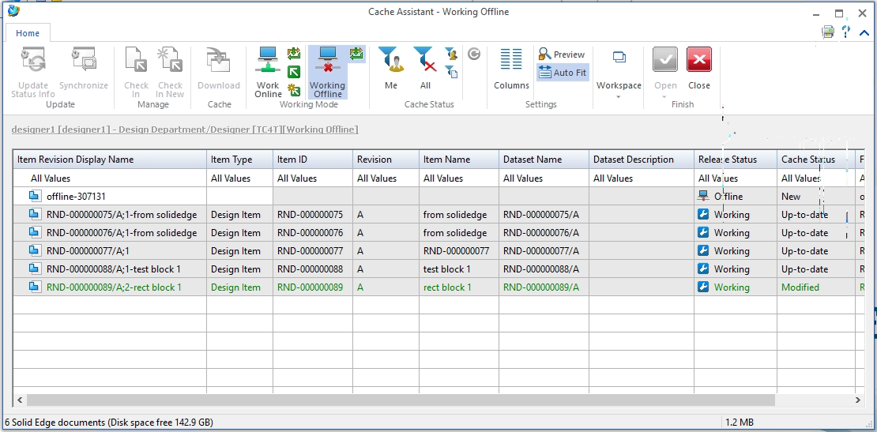

Open and save the part and do check –In operation .

Log in into teamcenter and check the changes reflected.

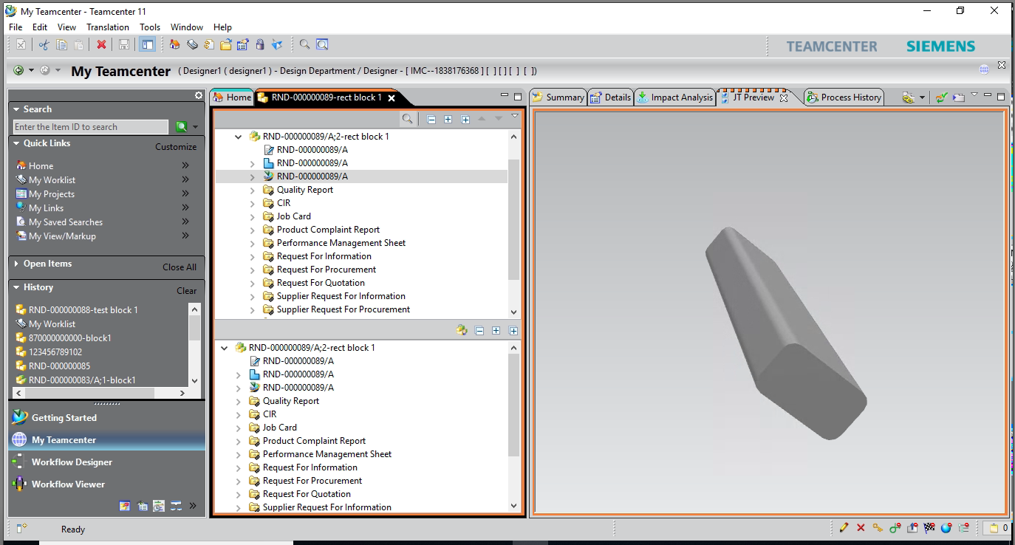

For assembly:

Create an assembly file offline.

Note: you need to first save the assembly file before adding components to it otherwise you wont be able to create an assembly offline.

After creating and saving assembly file add component to the assembly.

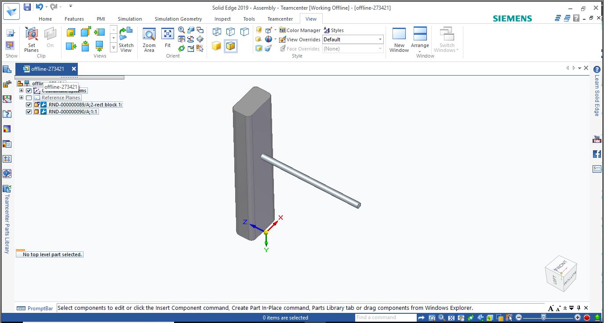

Perform Cntrl+S operation on assembly.

Now change the working mode from offline to workonline.

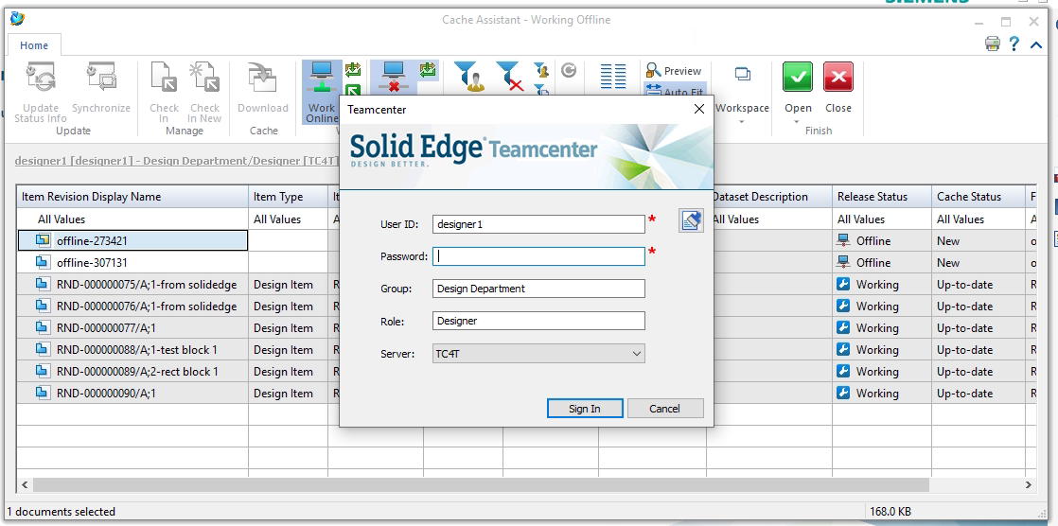

Enter the login details and click sign in

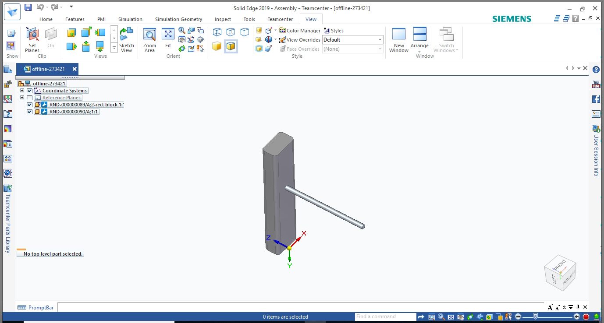

Click on check in button to check in , into teamcenter

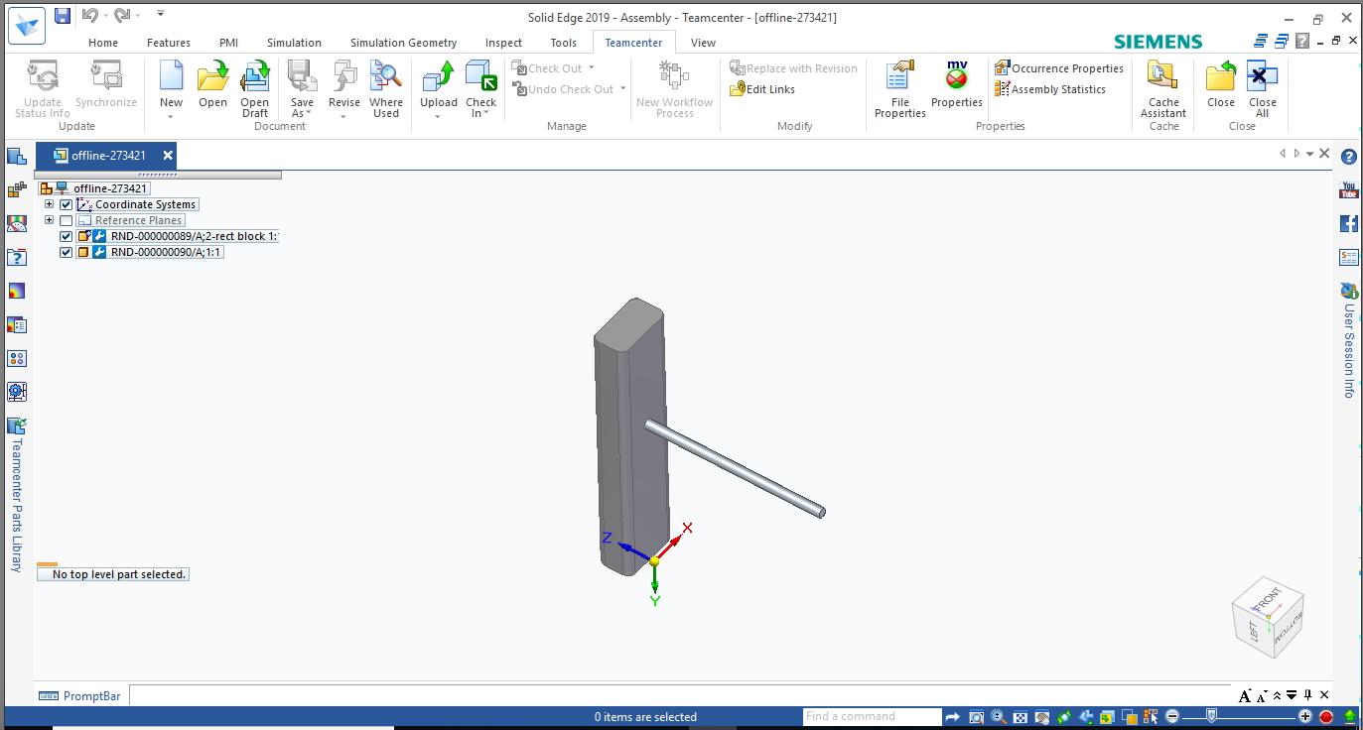

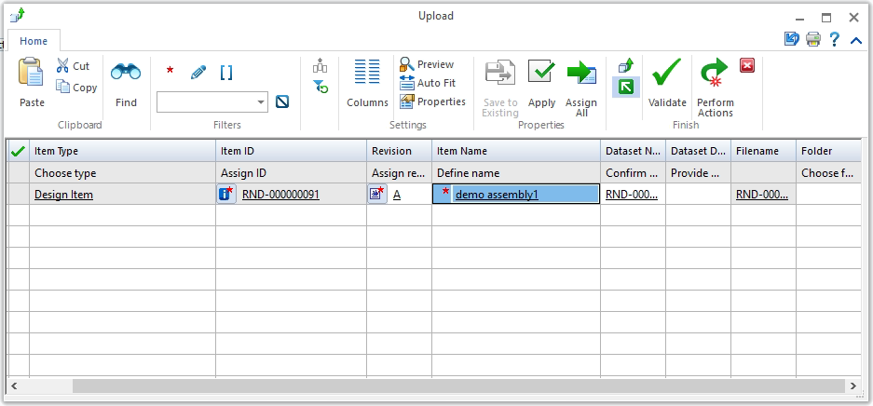

Now after check – in login into teamcenter and search the assembly

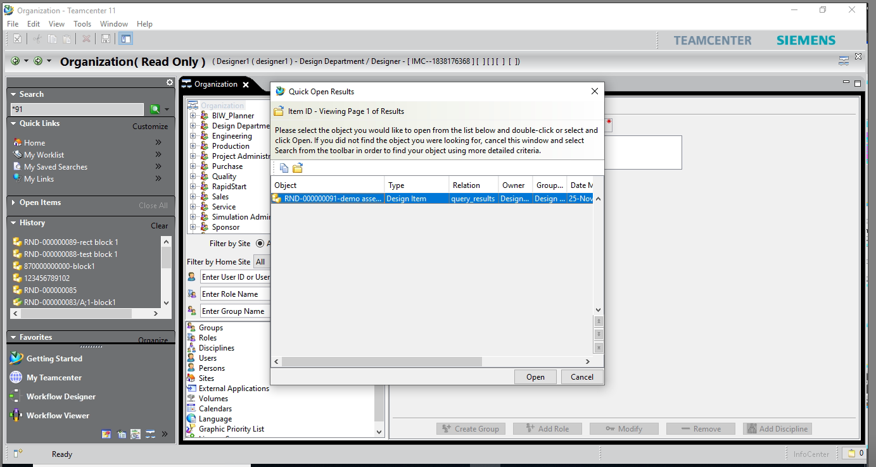

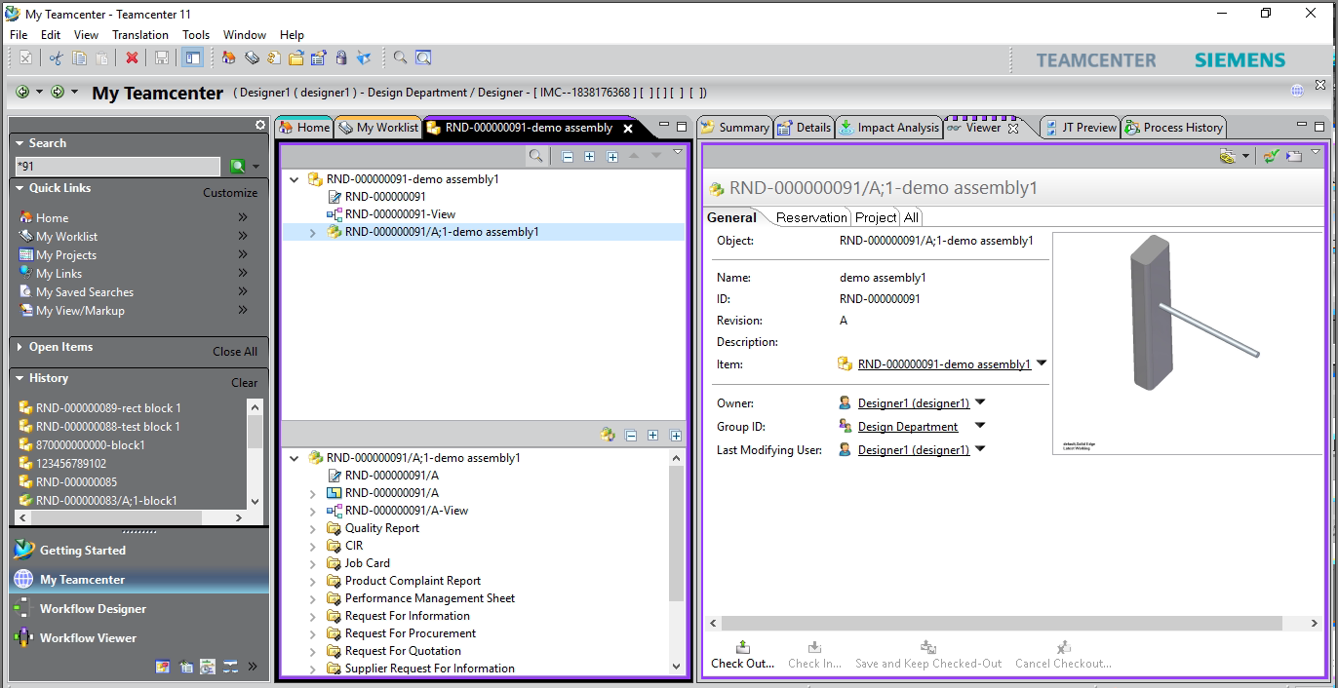

Now to modify the existing assembly and work in offline mode first check out the assembly from solid edge.

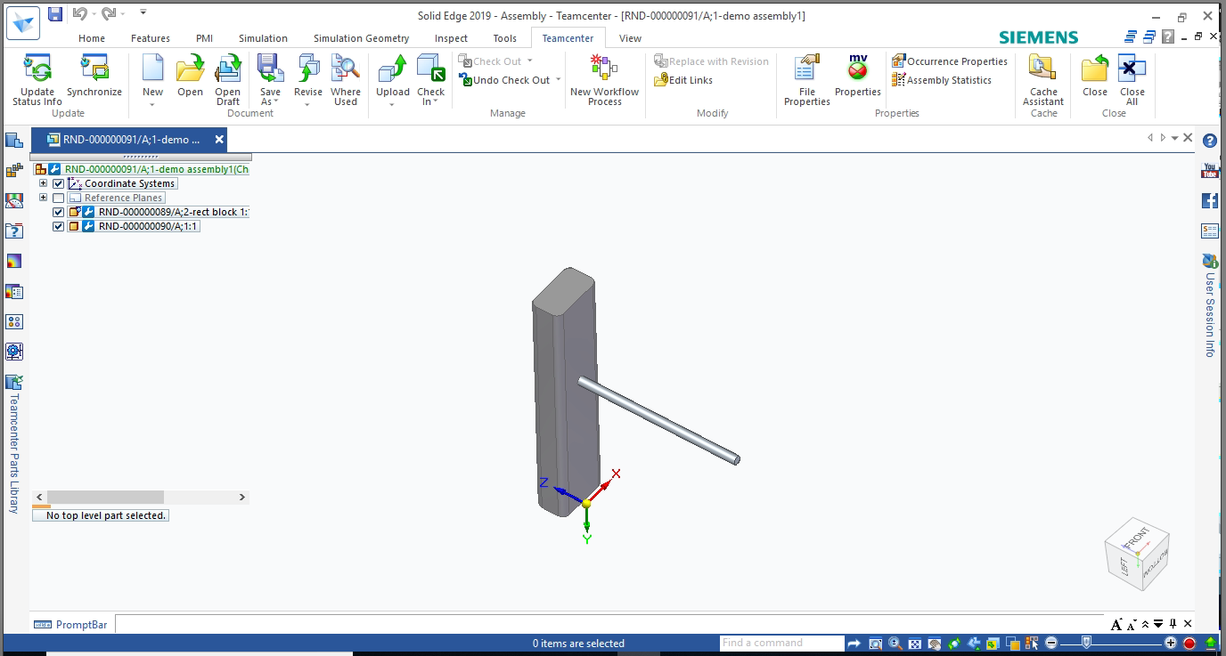

Select manage🡪 cache assistance 🡪 working offline 🡪select assembly to open and click open

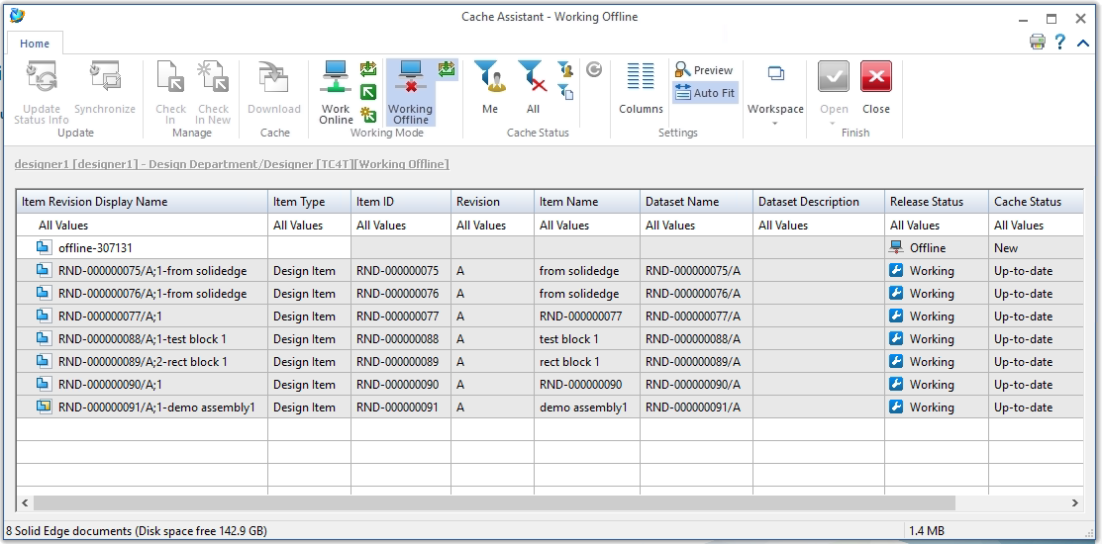

Modify the assembly and save it

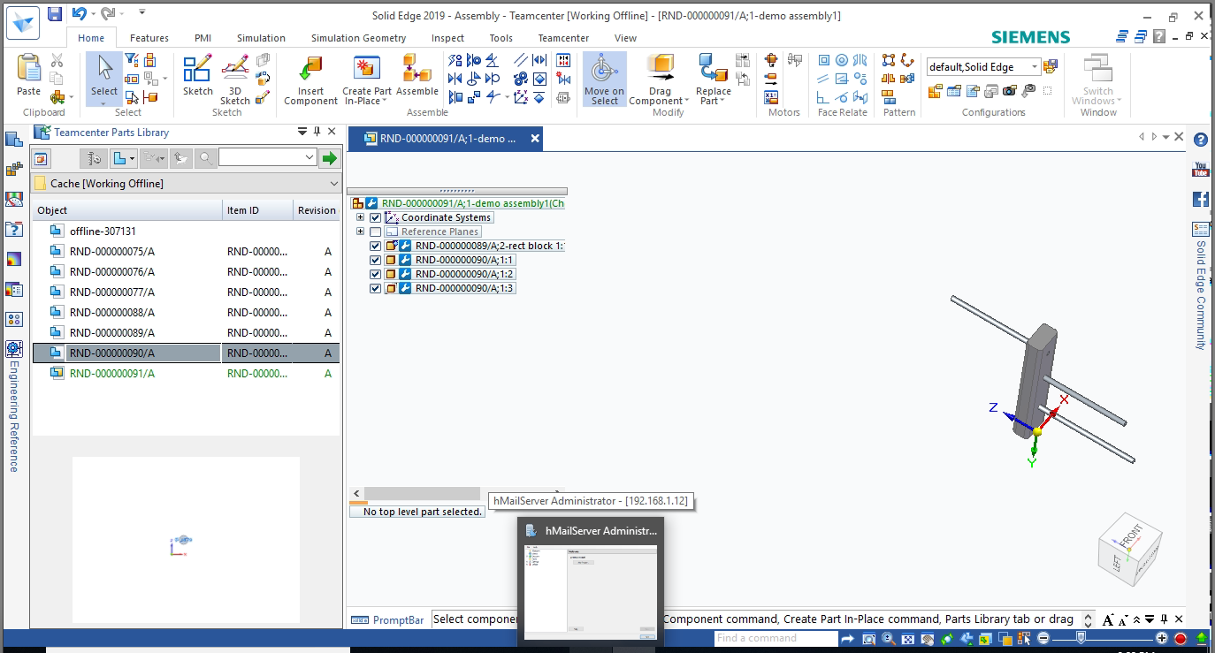

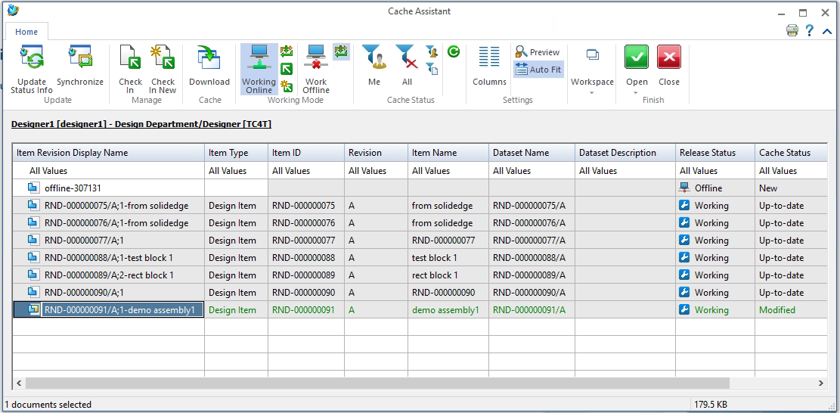

Check the changes in teamcenter.

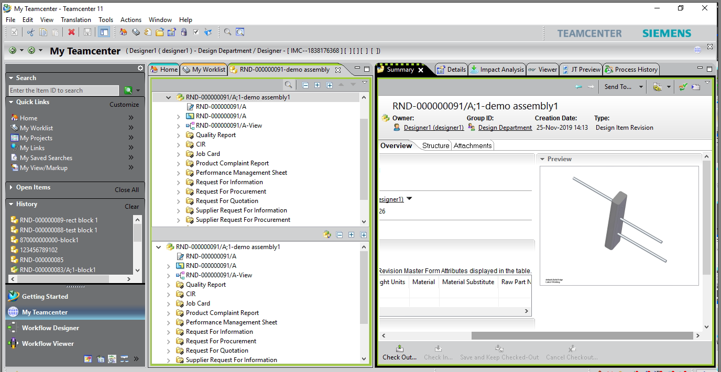

Assembly can be seen in teamcenter.